COUCHBASE Capella Workshop

**Lab Handbook**

Lab 1: Couchbase SQL ++

# Lab Description

In this section we will explore running N1QL queries on Couchbase Capella.

We will perform the following steps:

1. Run a N1QL query in the Query Workbench.
2. Access the Query workbench
3. Run the N1QL Query in the Query Workbench
4. Access the Visual Query plan
5. Create a Covering Index
6. Re-execute the query from step 1 and evaluate the results

# 

# Signing In

Go to [cloud.couchbase.com](https://cloud.couchbase.com/)

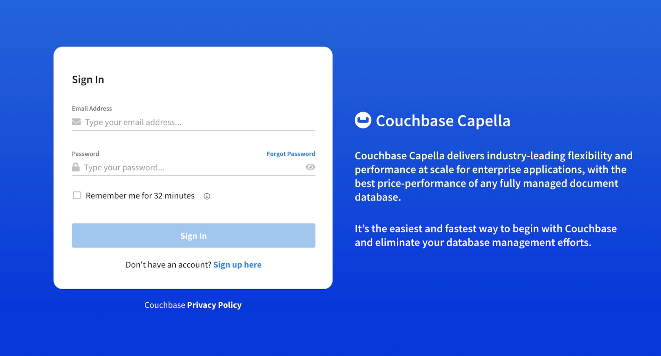

## 

## Step 1: Access the Query Workbench

Access the Query Workbench in the Couchbase Capella Cluster by selecting *Query* Workbench from the tools dropdown.

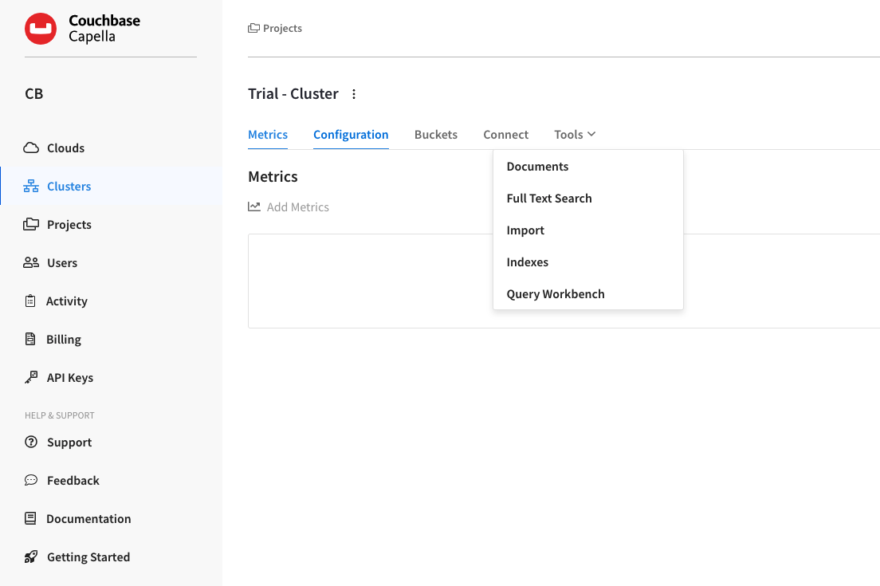

Below show basic steps to enter & execute N1QL Queries

| SELECT *  FROM `travel-sample` r  JOIN `travel-sample` a  ON r.airlineid = META(a).id  WHERE a.country = "France" |
| --- |

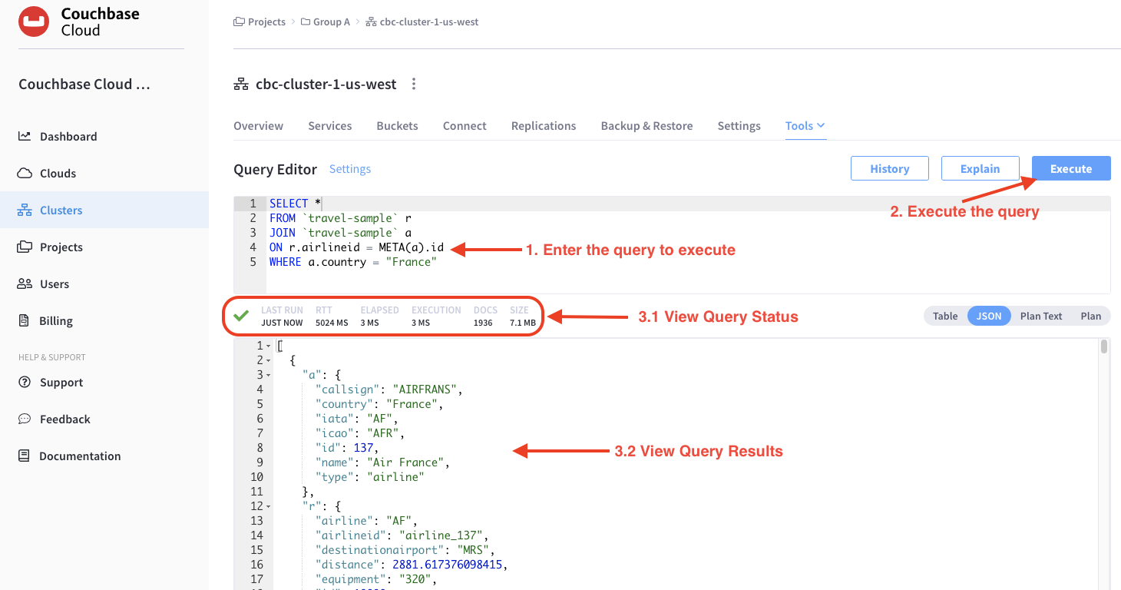

# 

**Understanding Query Workbench**

**Note:** The Query Workbench only runs on nodes which are running the Query service. If the Query service is *not* running on the current node, it provides a link to the nodes in the cluster which *are* running the Query service.

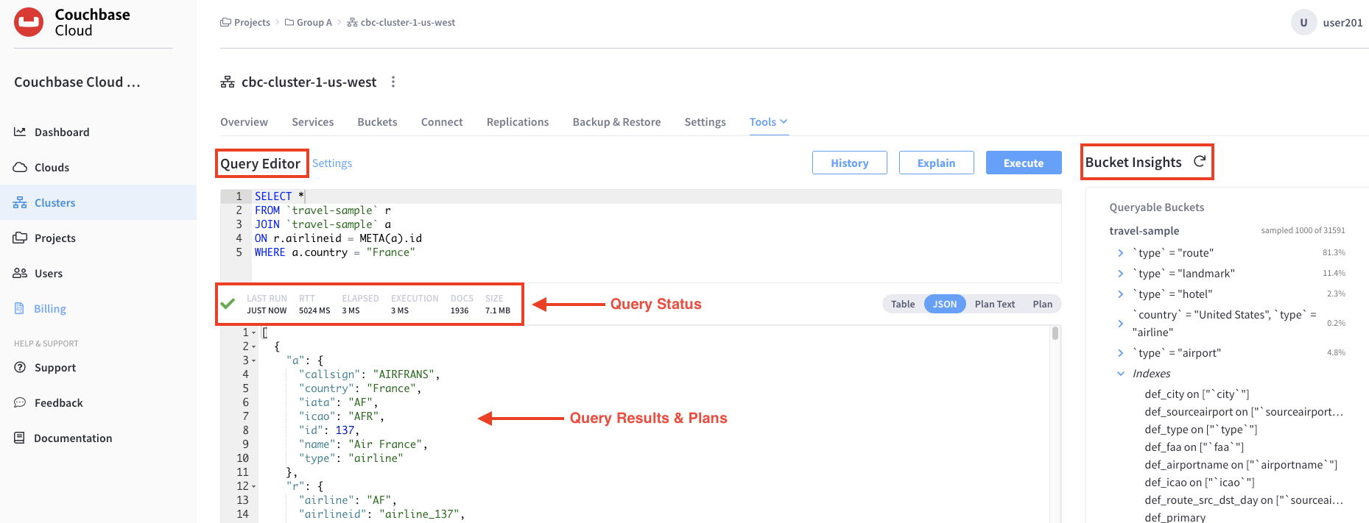

**Query Editor** is where you build queries, and run the queries using the Execute button.

**Bucket Insights** area displays all installed buckets in the cluster. By default, when the Query Workbench is first loaded, it retrieves a list of available buckets from the cluster. The Data Insights area is automatically refreshed when buckets or indexes are added or removed.

* **Fully Queryable Buckets:** Contain a primary index or a primary index and secondary indexes.
* **Queryable on Indexed Fields:** Do not contain a primary index, but have one or more secondary indexes.
* **Non-Indexed Buckets:** Do not contain any indexes. These buckets do not support queries. You must first define an index before querying these buckets.

**Viewing Query Results & Plans**

When you execute a query, the results are displayed in the Query Results area. Since large result sets can take a long time to display, we recommend using the [LIMIT](https://docs.couchbase.com/server/current/n1ql/n1ql-language-reference/limit.html) clause as part of your query when appropriate.

When a query finishes, the query metrics for that query are displayed below the Query Editor.

## Step 2: Run a N1QL query in the Query Workbench

Run the following N1QL select statement using the **Query Workbench** to fetch all the states/cities that have hotels in the state of California.

| SELECT state,city  FROM `travel-sample`  WHERE type="hotel" AND state = "California"; |
| --- |

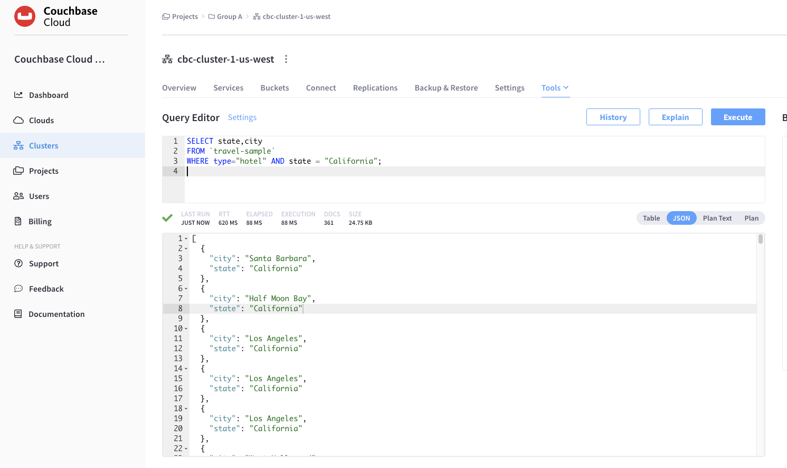

Press the *Plan* button and take a look at the visual query plan, as shown here:

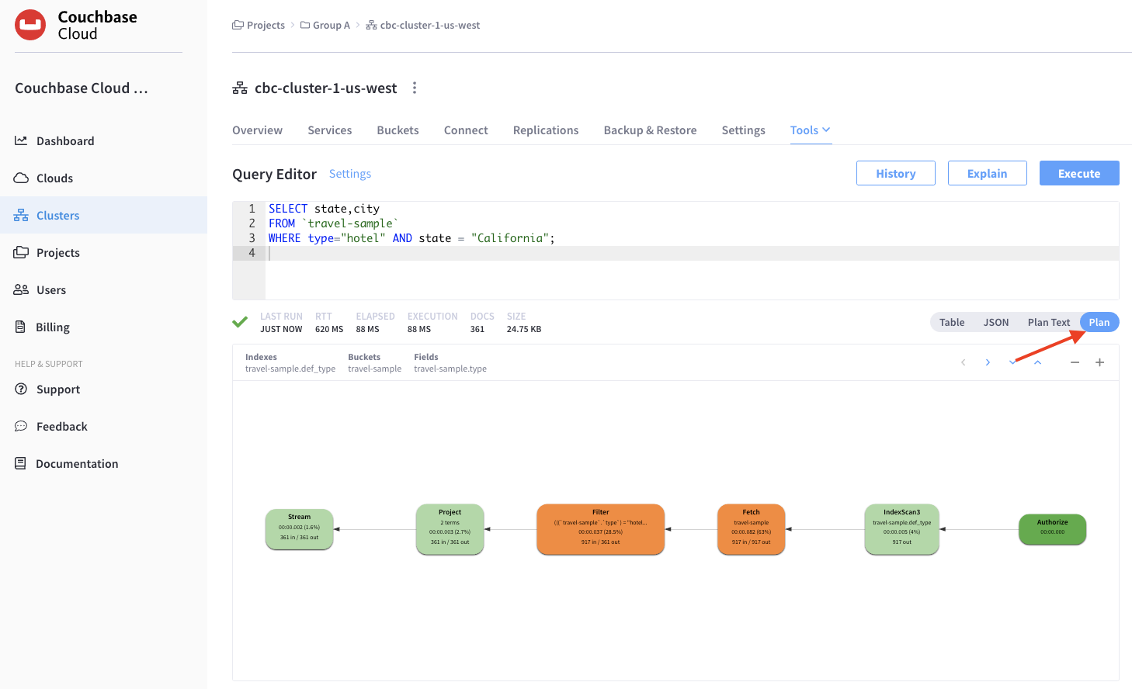

## Query Plans

Each time a query is executed, an [EXPLAIN](https://docs.couchbase.com/server/current/n1ql/n1ql-language-reference/explain.html) command is automatically run in the background to retrieve the query plan for that query.

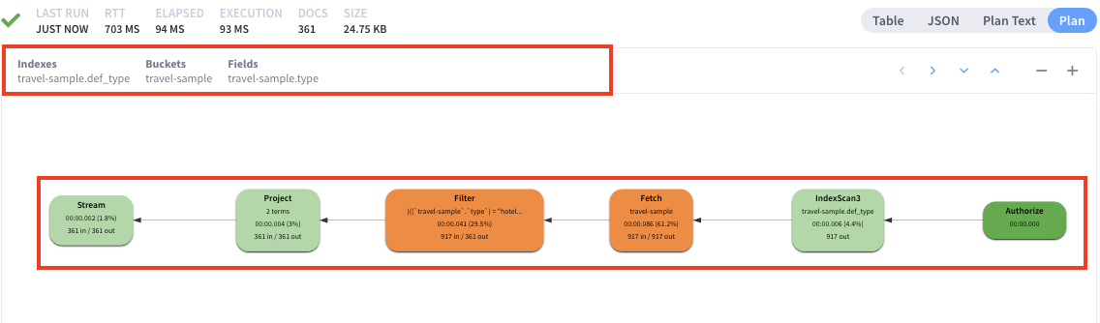

➀ At the top, it shows a summary which also shows lists of the buckets, indexes, and fields used by the query.

➁ At the bottom is a data-flow diagram of query operators, with the initial scans at the right, and the final output on the left. Potentially expensive operators are highlighted.

The data flow generally follows these steps:

1. Scan
2. Fetch
3. Filter
4. Projection (part 1)
5. Order
6. Projection (part 2)

Clicking on any unit of the plan shows more details of it.

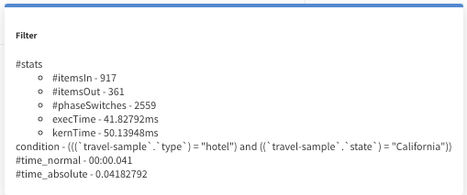

Notice that its currently using the index **travel-sample.def_type** as indicated by

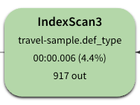

STOP until further instructions

## Step 3: Create a covering index

**Covering Indexes**

When an index includes the actual values of all the fields specified in the query, the index covers the query and does not require an additional step to fetch the actual values from the data service. An index, in this case, is called a covering index and the query is called a covered query. As a result, covered queries are faster and deliver better performance.

Before creating a covering index for the query, please execute the ADVISE command and take a look at the “**recommended_indexes**” section.

| **ADVISE SELECT** state,city  **FROM** `travel-sample`  **WHERE** type="hotel" AND state = "California"; |
| --- |

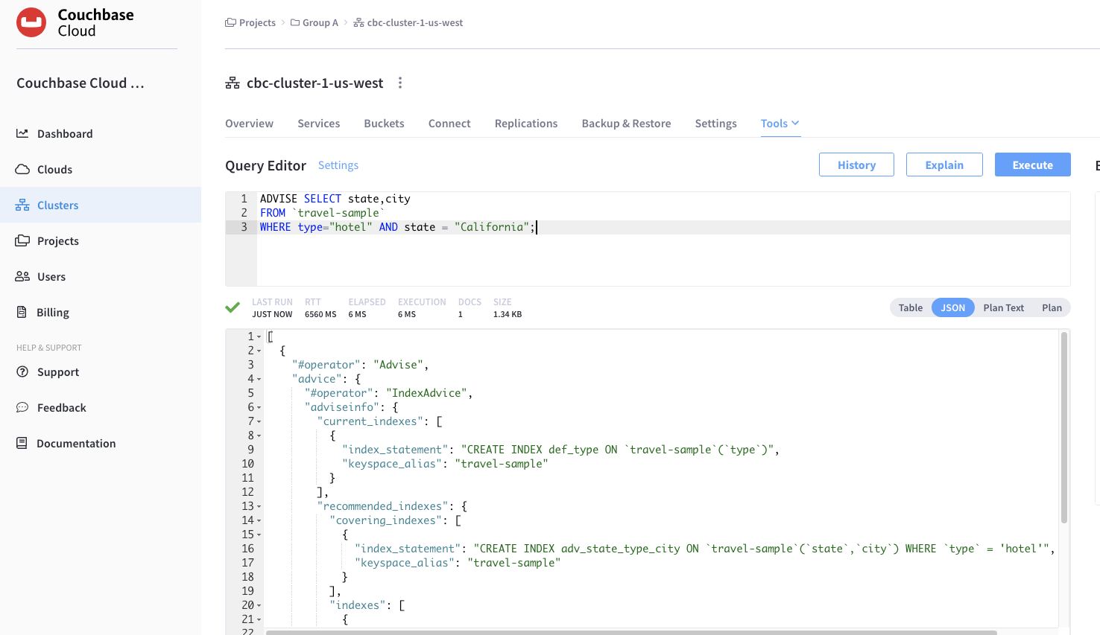

******************************************************************************************************************************

**STOP: FOR REFERENCE ONLY. DO NOT EXECUTE**

******************************************************************************************************************************

Instructor will execute the following statement to define an index with the state and type and city attributes

| CREATE INDEX **idx_state_city** on `travel-sample` (state, type, city) USING GSI; |
| --- |

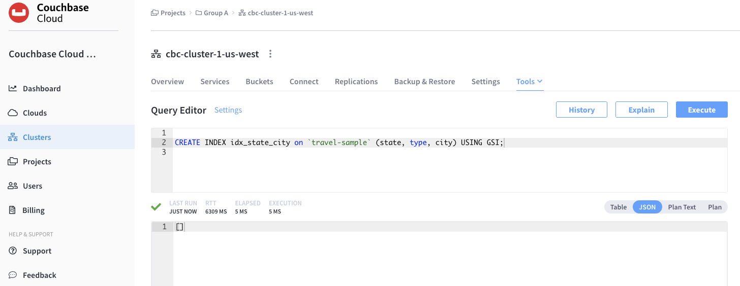

******************************************************************************************************************************

## Step 4: Re-execute the query from Step 2

Run the following N1QL select statement using the **Query Workbench** to fetch all the stat/cities that have hotels from the state of California.

| SELECT state,city  FROM `travel-sample`  WHERE type="hotel" AND state = "California"; |
| --- |

Press the *Plan* button and take a look at the visual query plan, as shown here:

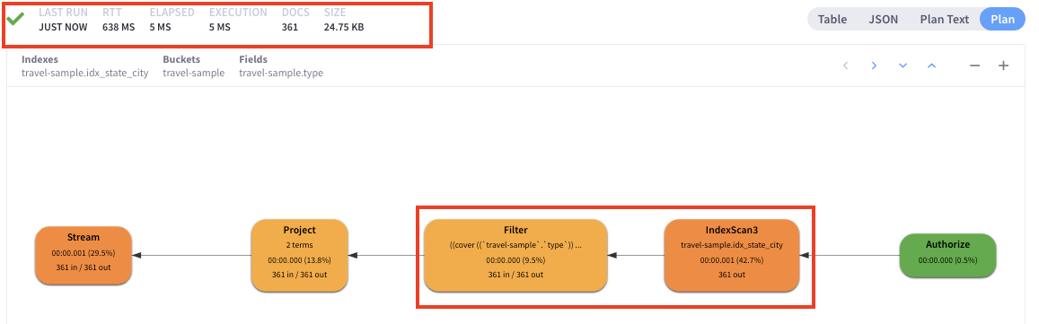

Notice that the query is now using the newly created index **idx_state_city**

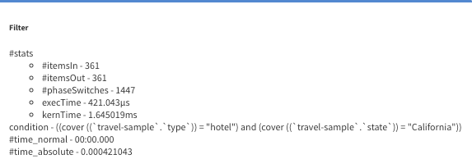

**Please take a look at the execution times of the queries before and after creating the covering index.**

## 

## 

## 

## 